AIM OF THE EXPERIMENT:
To determine the coefficient of permeability of a given soil sample by Variable head permeability test.

APPARATUS REQUIRED:
- Special:
- Jodhpur permeameter frame consisting of sand pipe graduated scale, rubber tubing connected to permeameter mould.
- Permeameter mould.
- Accessories of permeameter mould including the cover, base, detachable collar, porous stones, dummy plate etc.
- Round filter paper.
- Dynamic compaction device.
- General:
- Stop watch.
- De-aired water.
- IS 4.75 mm sieve
- Grease.
THEORY:-
Permeability is defined as the property of porous material which permits the passage or seepage of water through its interconnected voids. The coefficient of permeability is finding out following method.

- Laboratory method:
- Variable head test.
- Constant head test.

- Field method:
- Pumping out test.
- Pumping in test.
- Indirect test:
- Computation from grain size or specific surface.
- Horizontal capillarity test.
- Consolidation test data.

The derivation of the coefficient of permeability is based on the assumption of the validity of the Darcy’s law to the flow of water in soil. The term coefficient of permeability implies the velocity of flow of water through the soil under unit hydraulic gradient, and consequently has the same units as that of velocity.

- Variable head test:
The variable head test is used for fine grained soils like silts and silty clays.
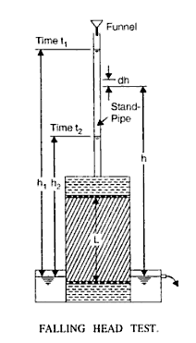
For the Variable head test the following formula is applicable:

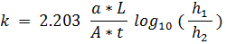
Where, k = Coefficient of permeability at Tº C (cm/sec).
a = Cross Sectional area of stand pipe (cm2).
L = Length of soil specimen (cm)
A = Cross-sectional area of soil sample inside the mould (cm2)
t = (t1 – t2) = Time interval for the head to fall from h1 to h2.
h1 = Initial head of water at time t1 in the pipe, measured above the outlet.
h₂ = Final head of water at time t2 in the pipe, measured above the outlet.

- Constant head test:
The Constant head test is suitable for coarse grained soils like sands, sandy silts.
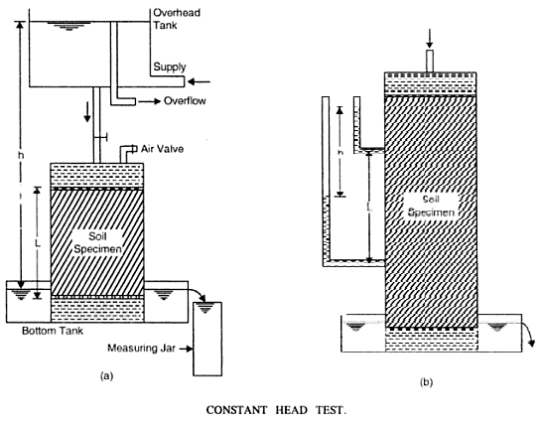
For the Constant head test the following formula is applicable:
if Q is the total quantity of flow in a time interval t, we have from Darcy’s low,
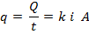
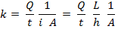
Where, k = Coefficient of permeability at Tº C (cm/sec).
L = Length of soil specimen (cm)
A = Total cross-sectional area of soil sample (cm2)
i = hydraulic gradients.
Q = Quantity of water collected in measuring jar.
t = total time required for collecting ‘Q’ quantity of water.
h = Difference in the water levels of the overhead and bottom tank.
APPLICATION:
Water flowing through soil exerts considerable seepage force which has direct effect on the safety of hydraulic structures.
The rate of settlement of compressible clay layer under load depends on its permeability. The quantity of water escaping through and beneath the earthen dam depends on the permeability of the embankments and its foundations respectively. The rate of discharge through wells and excavated foundation pits depends on the coefficient of permeability of the soils. Shear strength of soils also depends indirectly on its permeability, because dissipation of pore pressure is controlled by its permeability.
The table below gives rough values of the coefficient of permeability of various soils:
Type of soil | Value of permeability (cm/sec)
Gravel | 10³ to 1.0
Sand | 1.0 to 10⁻³
Silt | 10⁻³ to 10⁻⁶
Clay | less than 10⁻³

According to U.S Bureau of Reclamations, soil are classified as follows:
Impervious | k less than 10⁻⁶ cm/sec
Semi-pervious | k between 10⁻⁶ to 10⁻⁴ cm/sec
Pervious | k greater than 10⁻⁴ cm/sec

PROCEDURE:
- Preparation of remoulded soil specimen:
- Weight the required quantity of oven dried soil sample. Evenly sprinkle the calculated quantity of water corresponding to the OMC. Mix the soil sample thoroughly.
- Clean the mould and apply a small portion of grease inside the mould and around the porous stones in the base plate. Weight the mould and attach the collar to it. Fix the mould on the compaction base plate. Keep the apparatus on solid base.
- The soil sample is placed inside the mould, and is compacted by the standard Proctor compaction tools, to achieve a dry density equal to the pre-determine3d MDD. Weight the mould along with the compacted soil.
- Saturate the porous stones. Place the filter papers on both ends of the soil specimen in the mould. Attach the mould with the drainage base and cap having saturated porous stones.

- Saturation of soil specimen:
- Connect the water reservoir to the outlet at the bottom of the mould and allow the water to flow in the soil. Wait till the water has been able to travel up and saturate the sample. Allow about 1 cm depth of free water to collect on the top of the sample.
- Fill the remaining portion of cylinder with de-aired water without disturbing the surface of soil.
- Fix the cover plate over the collar and tighten the nuts in the rods.

- Constant head test:
- Place the mould assembly in the bottom tank and fill the bottom tank with water up to the outlet.
- Connect the outlet tube with constant head tank to the inlet nozzle of the permeameter, after removing the air in flexible rubber tubing connecting the tube.
- Adjust the hydraulic head by either adjusting the relative hight of the permeameter mould and constant head tank or by rising or lowering the air intake tube with in the head tank.
- Start the stop watch and at the same time put a bucket under the outlet of the bottom tank, run the test for same convenient time interval and measure.
- Repeat the test twice more, under the same head and for the same time interval.

- Variable head permeability test method:
- Disconnect the water reservoir from the outlet at the bottom and connect the stand pipe to the inlet at the top plate.
- Fill the stand pipe with water. Open the stop cock at the top and allow water to flow out so that all the air in the cylinder is removed.
- Fix the height h1 and h2 on the stand pipe from the centre of the outlet such that (h1 – h2) is about 30 cm to 40 cm.
- When all the air has escaped, close the stop clock and allow the water from the pipe to flow through the soil and establish a steady flow.
- Record the time interval, t, for the head to drop from h1 to h2.
- Take about five such observations by changing the values of h1 and h2.
- Measure the temperature of water.
PRECAUTIONS:
- All possible leakage of joints must be eliminated.
- Porous stones must be saturated before being put to use.
- De-aired and distilled water should be used to prevent choking of flowing water.
- Soil sample must be carefully saturated before taking the observations.
- Use of high heads, which result in turbulent flows, should be avoided.
OBSERVATION AND CALCULATION TABLE FOR CONSTANT HEAD PERMIABILITY TEST:
S No | OBSERVATION | 1 | 2 | 3
1 | Diameter of stand pipe (cm) ‘d’ | 1.0 | 1.1 | 1.2
2 | c/s area of stand pipe ‘a = πd²/4
3 | Diameter of cylindrical soil sample D
4 | c/s area of soil specimen ‘A = πD²/4
5 | Height of soil specimen, L
6 | Hydraulic head ‘h’ (cm)
7 | Time interval ‘t’ (sec)
8 | Coefficient of permeability (cm/sec)  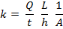
Avg. Coefficient of permeability (cm/sec) = _____________
OBSERVATION AND CALCULATION TABLE FOR FOLLOWING HEAD PERMIABILITY TEST:
Table 1:
Sr no. | Observation | 1 | 2 | 3
1 | Diameter of stand pipe (cm) ‘d’ | 1.0 | 1.1 | 1.2
2 | c/s area of stand pipe ‘a = πd²/4
3 | Diameter of cylindrical soil sample D
4 | c/s area of soil specimen ‘A = πD²/4
5 | Height of soil specimen, L
Table 2:
Sr. No. | Initial Head  (h₁) cm | Final Head  (h₂) cm | Time required (t) sec | Permeability,
1
2
3

QUESTIONNAIRE:
- What is Darcy’s law of flow velocity through soils? What are its Limitations?
- What are the steady and unsteady flows of water? What type of flow is assumed to occur in soils?
- What are the laboratory methods of determination of coefficient of permeability of soil? State their suitability.
- What is the effect of entrapped air on the coefficient of permeability of soil?

- Constant head method is suitable for _________ type of soils
- Coarse grained soils
- Fine grained soils
- Cohesive soils
- Cohesion less soils
- Variable head test is suitable for _______ type of soils
- Coarse grained soils
- Fine grained soils
- Cohesive soils
- Cohesion less soils
- Which test is used to find the coefficient of permeability of a partially saturated soil
- Constant head method
- Variable head test
- Capillary permeability test
- Consolidation test data
- For a fully saturated soil ______ is the permeability
- More
- Less
- Zero
- Both a & b
- Coefficient of permeability by variable head test is given by
- 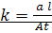ln(h1/h2)
- 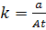ln(h2/h1)
- 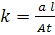ln(h2/h1)
- ln(h1/h2)
- If size of the particle increases 2 times then K increases to
- 4 times
- 2 times
- Decreases
- Remains same
- Soil with largest void ratio have ______permeability
- Less
- More
- Equal
- Zero
- Due to change of temperature, the ᵞw and µ of the liquid reduced by 10% and 40% respectively. What is the change in the permeability of the soil
- Reduces by 10%
- Reduces to 90%
- Reduces by 40%
- Both a & b
- Permeable soil has a K (cm/sec)value of
- >0.1
- <0.1
- =0
- None
- Coefficient of permeability is also called as
- Hydraulic conductivity
- Conductivity
- Energy of water
- Potential of water

PART – 2
ANIMATION STEPS
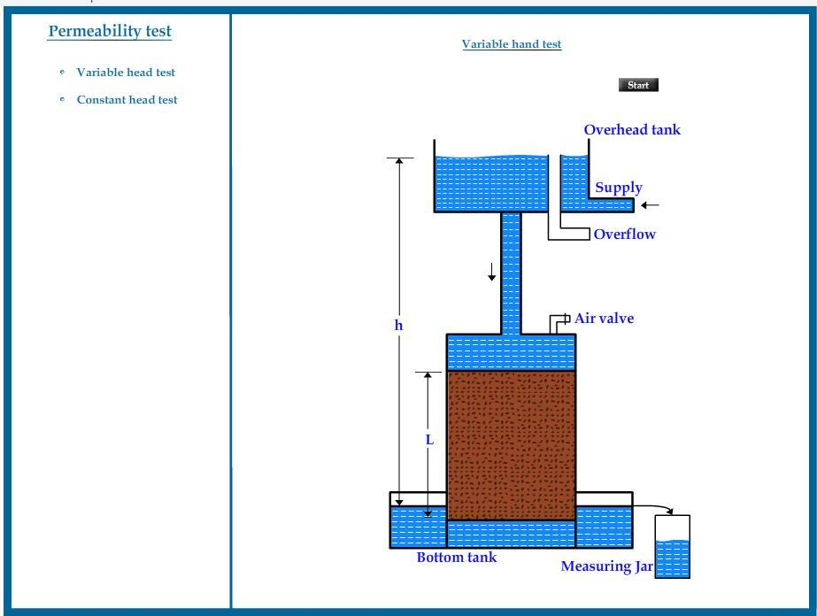

PART – 3
VIRTUAL LAB FRAME
